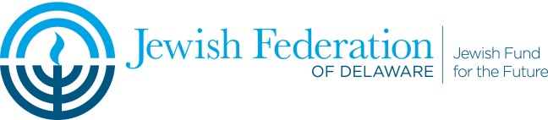

Goldinger Trust Application

*The Goldinger Trust is for the purposes of “promoting and expanding agricultural research for food and fiber and animal science in Israel”*

Applications should be 2 pages or less, font size 12, and must follow the headings listed below as they apply to your request. Please create a new word document using the Application Headings listed below. The review committee is looking for the potential utility of the research to Israel. The Fund will accept applications for early-stage development programs.

In a separate document (or as a third page) applicants should include a non-confidential project summary (200 words or less) that may be shown to a third party.

Note: For multi-year requests, an acceptable progress report must be submitted before additional funds are released.

*Application deadline: Friday, October 24, 2025*

Grant distributions are anticipated to be made in December

Application Headings

Organization:

Name, Address, Primary Contact, Phone, Email.

Project:   
 Name, Total program budget, Dollar amount requested.

Purpose:

Basic Research: 1. Novelty and scientific basis

2. Potential utility of results

Development programs: 1. Product concept – route to market.

2. Potential impact on the Israel economy

Related Work: If the proposed work is a component of a larger project or of a collaboration, please describe that related work, and how your proposed project fits into the larger project.

Scientific/technical status of field:

1. Competitive landscape
2. Current state of the art as it relates to your proposed project

 Program Plan:

1. Goals
2. Methodology
3. Quantitative milestones

 Resources:

1. Key researchers: (If the proposed work will be under the supervision of or performed in collaboration with anyone but yourself, please state his/her name and relationship to the project).
2. Facilities: (Please describe what facilities and equipment you will require to perform your project, and clearly distinguish what you will have available to you from what you will need to acquire. Provide the estimated cost of facilities or equipment needed).
3. Collaborations: (List any other organizations or businesses you are partnering with for this project).
4. Other funding: (Please provide a spreadsheet showing a full breakdown of estimated costs, whether you have funding beyond the $20,000 you seek herewith, and if so, from what source. If you have applied for other funding but have not yet received it, please state what amount and from whom).

Market Potential/Jobs in Israel:

Please describe in 200 words or less the market potential and job potential in Israel in the next 5-10 years related to your technology.

Applicants should also include a separate non-confidential project summary (200 words or less) that may be shown to a third party.

H:/Gina/Goldinger/2025 Goldinger Grant Application