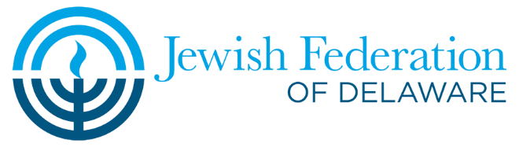
Sample Follow-Up Email: ​
No Working Phone Number

Subject Line: Jewish Federation of Delaware’s Super Sunday
Dear__________________,
I am reaching out to you today on behalf of Jewish Federation’s Super Sunday. During this challenging year, Federation has made a significant effort to support our Jewish family, locally and around the world. I want to thank you for your very generous support of the 2021 Annual Campaign, and respectfully request your consideration in making a pledge now for the 2022 Annual Campaign. I am pleased to share with you this powerful video, which will show you more about the difference that Federation has made this year. I would appreciate your reply to inform us of your pledge for the 2022 Campaign or you may make your pledge online by clicking here. Please know that your gift truly makes a difference. If you have any questions, please contact the Federation office at (302)427-2100. Thank you!
With sincere gratitude,
_________________________
(Your Name)

P.S. Please “Like” “Follow” and “Share” our Facebook, Twitter and Instagram pages!

