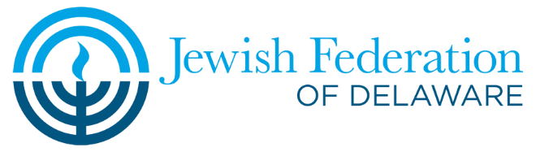
Sample Follow-Up Email: ​
Thank You for Your Pledge!

Subject Line: Thank You for Your Generous Pledge to Federation’s Annual Campaign!

Dear______________,
Thank you for answering my call and taking the time to speak to me on behalf of Federation’s Super Sunday. We are so grateful for your pledge of $_______ for the 2022 Annual Campaign. Your gift will make a significant and positive impact for our Jewish community here at home and around the world. I am pleased to share with you this powerful video, which will show you more about the difference that Federation has made this past year. YOU have helped to make that possible. Thank you!
Your 2022 Campaign pledge payment is due by December 31, 2022. If you wish to pay your pledge now, please click here.
With sincere gratitude,
_________________________________
(Your name)
P.S. Please “Like” “Follow” and “Share” our Facebook, Twitter, and Instagram pages!

